Welcome to worship. As our lives take on a new rhythm and we become accustomed to new ways of being God is still with us.

Still your minds, breathe deeply and prepare to worship God.

Call to Worship

Paraphrase of Psalm 19 by Rachel Poolman from URC Prayer Handbook 2020

God reaches out to all creation
from limitless heights and unfathomable depths,
breathing truth,
expanding love.

God’s mystery
sweeps across the skies,
pouring out beauty.

God’s wisdom
enters the darkest night,
sowing peace.

God drips sweetness
for us to taste
for us to share.

May your words
and our meditations
join the eternal dance of love.

This Photo by Unknown Author is licensed under CC BY-NC

HYMN For the beauty of the earth tunes Lucerna Laudoniae, Heathlands or John Rutter’s lovely setting
For the beauty of the earth,
For the beauty of the skies,
For the love which from our birth
Over and around us lies,
Lord of all, to thee we raise
This our grateful hymn of praise.
For the beauty of each hour
Of the day and of the night,
Hill and vale, and tree and flower,
Sun and moon and stars of light,
Lord of all, to thee we raise
This our grateful hymn of praise.
For the joy of human love,
Brother, sister, parent, child,
Friends on earth, and friends above,
Pleasures pure and undefiled,
Lord of all, to thee we raise
This our grateful hymn of praise.
For each perfect gift of thine,
To us all so freely given,
Graces human and divine,
Flowers of earth and buds of heaven,
Lord of all, to thee we raise
This our grateful hymn of praise.
For thy Church which evermore
Lifteth holy hands above,
Offering up on every shore
Her pure sacrifice of love,
Lord of all, to thee we raise
This our grateful hymn of praise.
F.S Pierpoint Copied under license number 88966

PRAYER
Think of something that has lifted your spirits this week
Pause and give thanks

Think of someone that has contacted you this week
Pause and give thanks

Think of someone who has served you this week
Pause and give thanks

God has been with us this week
Pause and give thanks

Gracious God
In this house, at this time, we set aside this space to worship you.
Bless this space, bless this house, bless this time.

As we wonder at your eternal mystery reaching out to all generations, past, present and to come, we humbly come before you.

As we come to seek the source of eternal wisdom, there to guide all generations, past, present and to come, we humbly come before you.

As we come to feel the warmth of your eternal love, there for all generations, past, present and to come, we humbly come before you.

We come in humility acknowledging that we sometimes want to make you cosy for ourselves but forget your mystery.
We so often trust our own wisdom, or the wisdom of others before we seek your wisdom.
We so often seek your love but then forget that this love is for all who we meet or hear about or see on our screens.

Forgive us,
forgive us our arrogance, our foolishness and our lack of love.
Forgive us when we dance to the world’s tune and not to the rhythm of eternity.

As we come to your word today, especially that spoken by your Son, Jesus Christ, still our minds and hearts and souls so that our thoughts and meditations can be focused on his life, his death and his resurrection from which your love and mercy flows to us and to all generations, past, present and to come.

Amen
THE LORD’S PRAYER
Our Father, who art in heaven,
Hallowed be thy Name.
Thy Kingdom come,
Thy will be done on earth, as it is in heaven.
Give us this day our daily bread.
And forgive us our trespasses, as we forgive them that trespass against us.
And lead us not into temptation but deliver us from evil.
For thine is the kingdom, The power, and the glory, For ever and ever. Amen

READINGS

Exodus 20 v 1-20

20 Then God spoke all these words:
² I am the Lord your God, who brought you out of the land of Egypt, out of the house of slavery; ³ you shall have no other gods before me.
⁴ You shall not make for yourself an idol, whether in the form of anything that is in heaven above, or that is on the earth beneath, or that is in the water under the earth. ⁵ You shall not bow down to them or worship them; for I the Lord your God am a jealous God, punishing children for the iniquity of parents, to the third and the fourth generation of those who reject me, ⁶ but showing steadfast love to the thousandth generation of those who love me and keep my commandments.
⁷ You shall not make wrongful use of the name of the Lord your God, for the Lord will not acquit anyone who misuses his name.
⁸ Remember the sabbath day, and keep it holy. ⁹ For six days you shall labour and do all your work. ¹⁰ But the seventh day is a sabbath to the Lord your God; you shall not do any work—you, your son or your daughter, your male or female slave, your livestock, or the alien resident in your towns. ¹¹ For in six days the Lord made heaven and earth, the sea, and all that is in them, but rested the seventh day; therefore the Lord blessed the sabbath day and consecrated it.
¹² Honour your father and your mother, so that your days may be long in the land that the Lord your God is giving you.
¹³ You shall not murder.
¹⁴ You shall not commit adultery.
¹⁵ You shall not steal.
¹⁶ You shall not bear false witness against your neighbour.
¹⁷ You shall not covet your neighbour’s house; you shall not covet your neighbour’s wife, or male or female slave, or ox, or donkey, or anything that belongs to your neighbour.
¹⁸ When all the people witnessed the thunder and lightning, the sound of the trumpet, and the mountain smoking, they were afraid and trembled and stood at a distance, ¹⁹ and said to Moses, ‘You speak to us, and we will listen; but do not let God speak to us, or we will die.’ ²⁰ Moses said to the people, ‘Do not be afraid; for God has come only to test you and to put the fear of him upon you so that you do not sin.’

Philippians 3 v 4b-14

If anyone else has reason to be confident in the flesh, I have more: ⁵ circumcised on the eighth day, a member of the people of Israel, of the tribe of Benjamin, a Hebrew born of Hebrews; as to the law, a Pharisee; ⁶ as to zeal, a persecutor of the church; as to righteousness under the law, blameless.
⁷ Yet whatever gains I had, these I have come to regard as loss because of Christ. ⁸ More than that, I regard everything as loss because of the surpassing value of knowing Christ Jesus my Lord. For his sake I have suffered the loss of all things, and I regard them as rubbish, in order that I may gain Christ ⁹ and be found in him, not having a righteousness of my own that comes from the law, but one that comes through faith in Christ, the righteousness from God based on faith. ¹⁰ I want to know Christ and the power of his resurrection and the sharing of his sufferings by becoming like him in his death, ¹¹ if somehow I may attain the resurrection from the dead.

Pressing towards the Goal
¹² Not that I have already obtained this or have already reached the goal; but I press on to make it my own, because Christ Jesus has made me his own. ¹³ Beloved, I do not consider that I have made it my own; but this one thing I do: forgetting what lies behind and straining forward to what lies ahead, ¹⁴ I press on towards the goal for the prize of the heavenly call of God in Christ Jesus.

Matthew 20 v 33-46
³³ ‘Listen to another parable. There was a landowner who planted a vineyard, put a fence around it, dug a wine press in it, and built a watch-tower. Then he leased it to tenants and went to another country. ³⁴ When the harvest time had come, he sent his slaves to the tenants to collect his produce. ³⁵ But the tenants seized his slaves and beat one, killed another, and stoned another. ³⁶ Again he sent other slaves, more than the first; and they treated them in the same way. ³⁷ Finally he sent his son to them, saying, “They will respect my son.” ³⁸ But when the tenants saw the son, they said to themselves, “This is the heir; come, let us kill him and get his inheritance.” ³⁹ So they seized him, threw him out of the vineyard, and killed him. ⁴⁰ Now when the owner of the vineyard comes, what will he do to those tenants?’ ⁴¹ They said to him, ‘He will put those wretches to a miserable death, and lease the vineyard to other tenants who will give him the produce at the harvest time.’
⁴² Jesus said to them, ‘Have you never read in the scriptures:
“The stone that the builders rejected
has become the cornerstone;
this was the Lord’s doing,
and it is amazing in our eyes”?
⁴³ Therefore I tell you, the kingdom of God will be taken away from you and given to a people that produces the fruits of the kingdom. ⁴⁴ The one who falls on this stone will be broken to pieces; and it will crush anyone on whom it falls.’
⁴⁵ When the chief priests and the Pharisees heard his parables, they realized that he was speaking about them. ⁴⁶ They wanted to arrest him, but they feared the crowds, because they regarded him as a prophet.

REFLECTION
I am sure we have all heard the saying ‘shrouds don’t have pockets’, and we smile to ourselves but we carry on living as if we own things. Technically I suppose there are things we ‘own’ but ‘you can’t take it with you’ is another saying that comes to mind. Again, we smile but we carry on as if some how it doesn’t apply to us – and we can always leave our valuable things to the next generation as their inheritance.
Having watched this last week the film ‘All the money in the world’, the story of the kidnap of John Paul Getty III and the dysfunctional family he was born into, one wonders what is inherited and what real value that has eventually. Yet even in the film there was a real twist in that everyone thought John Paul Getty I was the wealthiest man in the world – on paper he was – but all his money was tied up in trust funds so he personally had very little resources. This was a tax dodge of course, and we know how the wealthiest people in the world like to do that!
Yet this parable brings us up short – just like so many of the parables of Jesus. He tells the listeners that they are only tenants in someone else’s vineyard. They don’t own it, they only get the benefits of the grapes while they are tenants and indeed however much they look after or neglect the vineyard it is not theirs. This was a sobering thought – especially for the religious elite of the day who, even though the land was occupied by the Romans, had come to an accommodation with the ruling power and considered that eventually – once the Romans had gone – the land would be theirs again – just as God had promised to their ancestors.
This was their big misunderstanding. We have seen in the ‘small print’ of the 10 commandments that there are contingencies in them. There are expectations of a code of religious and social ways of being that the people are expected to follow. Honouring father and mother leads to a long time in the land – as is the very worship of God to the thousandth generation. No wonder the people were afraid and trembled and did the first social distancing recorded (that is a joke by the way!).
Yet this is also disconcerting for us as we are not used to thinking about God’s love for us being contingent on how we behave or indeed holding to all the commands. I was also relieved to read that the awful fate of those who reject Christ in v 44 is not present in some of the ancient texts. Yet – does this come from a place of arrogance, like the religious elite of Jesus’ own day? Are we in as much danger of claiming land, possessions cultural practices and even some of our beliefs as somehow ours by right rather than the gift of God. Do we act as if we were owners or act as if we are good tenants caring for what we have been given? In the light of all we know about what we are doing to the planet can we really be surprised if the planet bites us back in the processes we and previous generations have set in motion. Who are the prophets who have gone before and we have ignored – and indeed have we continued to ignore the owner’s Son too?
However, the context of the parable goes beyond our care for the planet. The Pharisees and Scribes were frightened of the crowd because they saw Jesus as a prophet. The general population were no saints – Jesus mixed with the ‘sinners and outcasts’ so this is not all about keeping to the commandments with every dot and iota, it is about that fundamental attitude and relationship with God. Paul counted all his external status symbols as nothing in the light of the love of God, through Christ, for him. He would never be good enough under the law, he could never live up to the commandments – and neither can we.
What Paul saw, and from which we get our hope is that in seeking to press on to follow as Christ would have us live – as caring, responsible, compassionate tenants in the world - then we will have gained everything. By not assuming we own anything, we have life in abundance. By not assuming we have rights, we gain the right to be called children of God. By having the humility to understand our place in the Kingdom of God, we are heirs of that Kingdom. By giving we receive, by dying to self we gain our true identity.
So, it is true in terms of what we ‘own’ that we can’t take it with us, but in terms of what we ‘are’, we take that on into eternity.
Amen
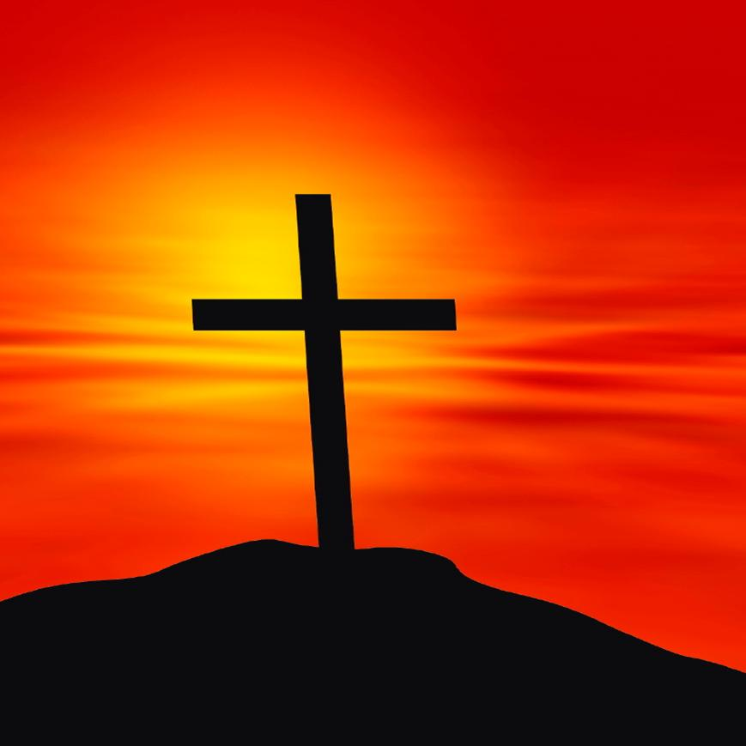
This Photo by Unknown Author is licensed under CC BY-NC-ND

PRAYERS
God of mystery, wisdom, truth and love we bring our prayers and concerns before you. Yet it so often feels like a list and that list increases rather than diminishes. We are conscious of so many needs in the world and we can feel overwhelmed and so our list grows until we almost become weary of praying. Yet Gracious God, you know the needs of the world, you know the places of conflict, the pain suffering and torture many endure. You do not need us to list them, yet we persist in our arrogance to think that only we can name them before you. Remind us that our petitions to you are as much about us as you, for as we bring these concerns to you, we are seeking your guidance about what we can do to make a difference.
May our prayers today be focused on listening to you in those situations we bring to mind…
(you are invited to name your concerns)
Yet, Loving God there are situations that we can only bring before you because that is the best and only thing we can do – for we are limited human beings…
(you are invited to bring those concerns before God)
Almighty God, may we act where we can, may we speak out where we must, may we give where we can and give us the wisdom to act, speak and give in ways that bring in your Kingdom of love, justice and peace. For the sake of Jesus Christ our Lord.
Amen

HYMN God in his love for us lent us this planet tune Stewardship
God in his love for us lent us this planet,
gave it a purpose in time and in space:
small as a spark from the fire of creation,
cradle of life and home of us all.

Thanks be to God for its bounty and beauty,
life that sustains us in body and mind:
plenty for all, if we learn how to share it,
riches undreamed-of to fathom and find.

Long have our human wars ruined its harvest:
long has the earth bowed to terror of force:
long have we wasted what others have need of,
poisoned the fountain of life at its source.

Earth is the Lord’s: it is ours to enjoy it,
ours, as his stewards, to farm and defend.
From its pollution, misuse and destruction,
good Lord, deliver us, world without end!

F. Pratt-Green copied under CCLI license number 88966

THE GRACE
The grace of our Lord Jesus Christ, the love of God and the fellowship of the Holy Spirit is with us all now and for evermore. Amen

If you search the internet you may well find the music to these hymns to sing along to.

There is a URC service available on the internet – at https://devotions.urc.org.uk or go to the URC website www.urc.org.uk and follow the links.

Hilary and Stephen

